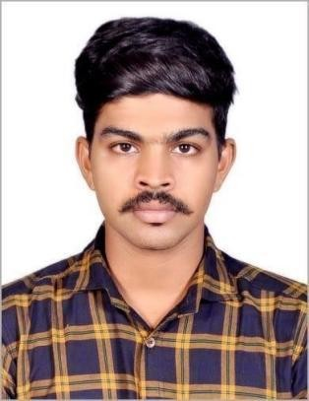

# PRASANTH. C S

✆: 9746980343 / 6369326374

: [prasanthcs799@gmail.com](mailto:prasanthcs799@gmail.com)

# CAREER SUMMARY

* Working as Electrician around 3.5 years of experience in industry.
* Good experience for the electrical section of the Maintenance Department
* Responsible in transactions for importing machines and equipment’s

# CAREER OBJECTIVE

To take up a challenging position in a prestigious concern with good communication skills and ability to Work under pressure. Fond of learning new things, looking forward to serve in open work culture that promotes Individual initiatives, growth and rewarding career.

# EDUCATION BACKGROUND

**Academic**: **S S L C**

Year-March 2012

University/Board: Board of publication Kerala

# Academic: PLUS TWO

Year-March 2014

University/Board: State Board of Tamil Nadu.

# Technical: Diploma in Electrical and Electronic Engineering

Year- 2014 to 2016 University/ Board: AICTE

# EXPERIENCE

* Currently working Electrical Technician in Mall of Travancore Present in December 2021
* Worked as Senior Technician Engineer Department in Sarovar hotel in Trivandrum December 2019 to January 2021.
* Worked as Electrical General Technician in Hycinth By Sparsa Hotel, Trivandrum from July 2017 to August 2019
* Worked as Training in Maintenance Department in Hycinth By Sparsa Hotel, Trivandrum from January 2017 to June 2017.

# PERSONAL PROFILE

Father’s Name : Chandrasekharan Nair

Date of birth : 18 Oct 1996

Sex : Male

Marital status : Single

Nationality : Indian

Religion : Hindu

Language Known : English and Malayalam Permanent Address : 2.132, Thamaravilagam Veedu,

Piracode,

Fathima Nagar (Post), Kanyakumari – 629160.

# DECLARATION:

I hereby declared that above mentioned Information furnished by me is true to the best of my knowledge and belief.

Place: Fathima Nagar With regards,

Date : **Prasanth. C S**